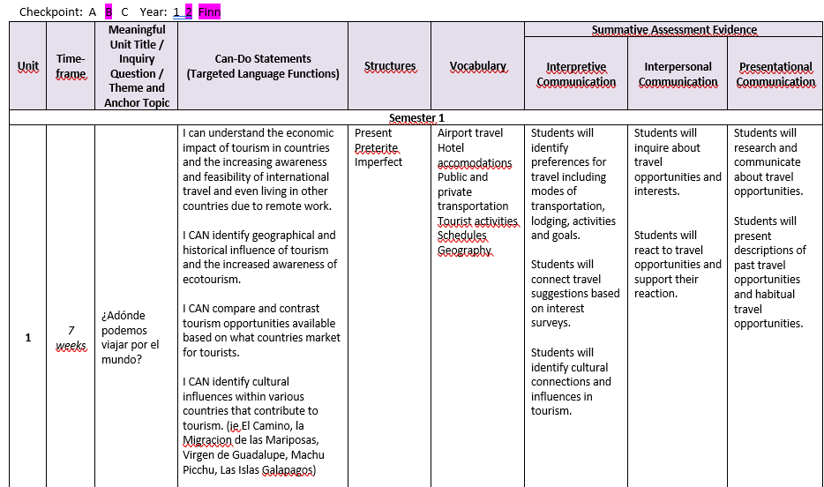

***Baseline: Novice High output***

1. Students will be given a baseline project that will review Checkpoint A communication levels and structures that will require them to investigate a Spanish speaking country and provide details about that country. Structures will be provided for review purposes and to promote accuracy at a NH level.

C:\Users\0480EFINN02\OneDrive - Allegany Limestone CSD\Country Projects\Country Projects\Viaje Project.docx (5 days creation, presentation, submission)

***Growth: Intermediate Low / Intermediate Mid input***

1. Students will read articles and listen to audio clips and videos on the following topics: (Interpretive Reading and Listening)
   1. The influence the Olympics have on tourism
   2. The influence religious pilgrimages have on tourism
   3. The influence the Incas and the Inca ruins have on Peruvian tourism
   4. The influence ecology has on the Ecuadorian tourism

***Baseline and growth: Novice High/ Intermediate Low output***

1. Students will write about what they have learned (Presentational writing)
2. Students will have conversations with peers and teacher about the articles (Interpersonal speaking)

***Growth: Novice High to Intermediate Low to Intermediate Mid***

1. Students will get direct instruction on the past tense so they are able to communicate about where they went, what they saw, what they learned on their virtual field trips.
2. Students will complete grill and drill practice to improve ability to communicate in the past tenses.

***Growth: Novice High to Intermediate Low to Intermediate Mid to “visting” Intermediate High***

1. Students will express their preferences and support their opinions in travel they would like to participate in in the future.

**Teacher goals based on MOPI training:**

Change wording of prompts. Where do you want to visit? 🡪 Tell me about the place you would like to visit and how it compares to your town.

What did you do there? 🡪 Tell me about one of the days you spent in that place.

Where would you like to go? 🡪 Tell me about your dream vacation.

**Teacher goals based on Assessment training:**

Provide assessments using questions at all levels. Lists, phrases, sentences, sentences with details, sentences with details with time stamps.

**Teacher goals for classroom organization and better questioning techniques:**

Classroom warmup activity that promotes question asking practice.

Provide a list of questions for students to pair and share and solidify Novice High accuracy

Classroom warmup activity that promotes vocabulary growth.

Questions that promote responses in complete sentences.

Ex: What are modes of transportation you prefer to take? Where would you like to sleep or stay?

What items do you need in your suitcase in order to travel? What are the steps you take to get through the airport?

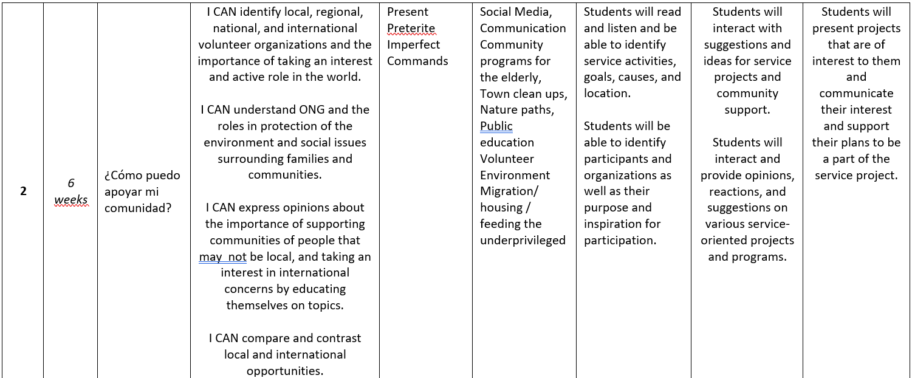

***Baseline: Novice High output***

1. Students will be identifying and communicating clubs, activities, programs offered here in our community that focus on teaching students the importance of community service. (Presentational Speaking and Writing)
2. Students will be communicating about their interest and participation level in various activities and programs. (Presentational Speaking and Writing) and (Interpersonal Speaking)

***Growth: Intermediate Low / Intermediate Mid input***

1. Students will read articles and listen to audios and videos that share information about national and international programs designed to assist and improve local and global economic issues.
2. Students will read articles and listen to audios and videos that share information about the importance of community support (Interpretive Reading and Listening)
3. Students will read articles and listen to audios and videos that share information about indigenous communities that work hard to maintain their individuality and culture, but lack support. (Interpretive Reading and Listening)

***Baseline and growth: Novice High/ Intermediate Low output***

1. Students will write about what they have learned including details and personal connections. (Presentational writing)
2. Students will have conversations with peers and teacher about the articles and include opinions and supporting details (Interpersonal speaking)

***Growth: Novice High to Intermediate Low to Intermediate Mid***

1. Students will get direct instruction on the past tense so they are able to communicate about what the community service need was, what specific actions were taken, and the results of those actions.
2. Students will complete grill and drill practice to improve ability to communicate in the past tenses.
3. Students will get direct instruction on the command forms in order to be able to communicate to others encouragement to participate in these activities and programs.
4. Students will complete some grill and drill practice on commands.

***Growth: Novice High to Intermediate Low to Intermediate Mid to “visting” Intermediate High***

1. Students will express their preferences and support their opinions in service programs or environmental issues that they would like to participate in in the future as well as communicate what they did in previous service projects. (Presentational Speaking and Writing) and (Interpersonal Speaking)

**Teacher goals based on MOPI training:**

Change wording of prompts. What is a service project that interests you. 🡪 Tell me about an environmental or service project that interests you.

What did you do to particpate? 🡪 Tell me about one of the projects you participated in.

What is something you can help with? 🡪 Tell me about something you plan to change about your habits or a service project you

plan to take an interest and participate in.

**Teacher goals based on Assessment training:**

Provide assessments using questions at all levels. Lists, phrases, sentences, sentences with details, sentences with details with time stamps.

**Teacher goals for classroom organization and better questioning techniques:**

Classroom warmup activity that promotes question asking practice.

Provide a list of questions for students to pair and share and solidify Novice High accuracy

Classroom warmup activity that promotes vocabulary growth.

Questions that promote responses in complete sentences.

Ex: Which service projects interest you? What are ways humans can help local and global communities?

What are some problems facing the world?

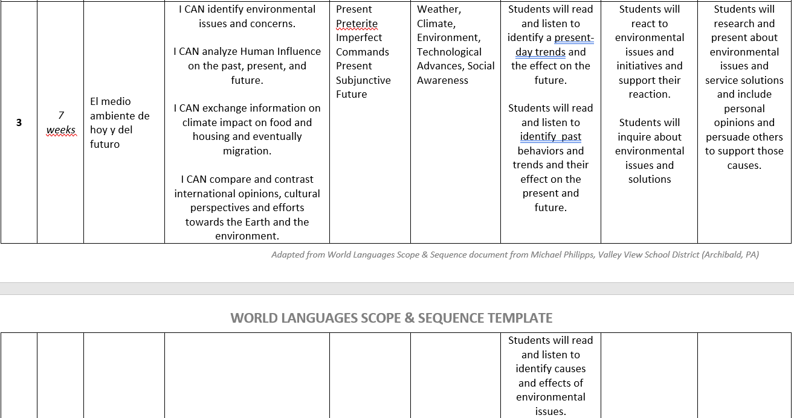

***Baseline: Novice High output***

1. Students will be identifying and communicating environmental problems and simple ideas to combat them. (Presentational Speaking and Writing)
2. Students will be communicating about their personal contributions to being mindful of the Earth and the environment. (Presentational Speaking and Writing) and (Interpersonal Speaking)

***Growth: Intermediate Low / Intermediate Mid input***

1. Students will read articles and listen to audios and videos that share information about national and international programs designed to assist and improve local and global environmental issues. (Interpretive Reading and Listening)
2. Students will read articles and listen to audios and videos that share information about the growing concern over access to clean water. (Interpretive Reading and Listening)
3. Students will read articles and listen to audios and videos that share information about environmental issues that lead to migration away from homelands. (Interpretive Reading and Listening)
4. Students will read about Mafalda, an Argentinian comic strip character whose message is the importance of caring for the planet. (Interpretive Reading)

***Baseline and growth: Novice High/ Intermediate Low output***

1. Students will write about what they have learned including details and personal connections. (Presentational writing)
2. Students will have conversations with peers and teacher about the articles and include opinions and supporting details (Interpersonal speaking)

***Growth: Novice High to Intermediate Low to Intermediate Mid***

1. Students will get direct instruction on the past tense so they are able to communicate about what the environmental problem was, what specific actions were taken, and the results of those actions.
2. Students will complete grill and drill practice to improve ability to communicate in the past tenses.
3. Students will get direct instruction on the command forms in order to be able to communicate to others encouragement to participate in changes to promote a healthier Earth.
4. Students will complete some grill and drill practice on commands.
5. Students will get direct instruction on the Future tense in order to be able to communicate what WILL happen if changes are or are not made.
6. Students will complete some grill and drill practice on the Future tense.

***Growth: Novice High to Intermediate Low to Intermediate Mid to “visting” Intermediate High***

1. Students will express their preferences and support their opinions on environmental issues that they are aware of and communicate how they plan to take an active role in promoting a healthier planet. (Presentational Speaking and Writing) and (Interpersonal Speaking)
2. Students will communicate some changes they have made in order to demonstrate a more active role in protecting our planet. (Presentational Speaking and Writing) and (Interpersonal Speaking)

**Teacher goals based on MOPI training:**

Change wording of prompts. What is a problem the Earth is facing? 🡪 Tell me about an environmental problem that concerns you.

What did you do to help the Earth? 🡪 Tell me about a change you have made to be more mindful of the Earth.

What is something you can help with? 🡪 Tell me about something you plan to change about your habits or a service project you

plan to take an interest and participate in.

**Teacher goals based on Assessment training:**

Provide assessments using questions at all levels. Lists, phrases, sentences, sentences with details, sentences with details with time stamps.

**Teacher goals for classroom organization and better questioning techniques:**

Classroom warmup activity that promotes question asking practice.

Provide a list of questions for students to pair and share and solidify Novice High accuracy

Classroom warmup activity that promotes vocabulary growth.

Questions that promote responses in complete sentences.

Ex: Which environmental issue concerns you the most and why?

What are changes businesses and companies have made to help with environmental issues? How do these problems affect you?

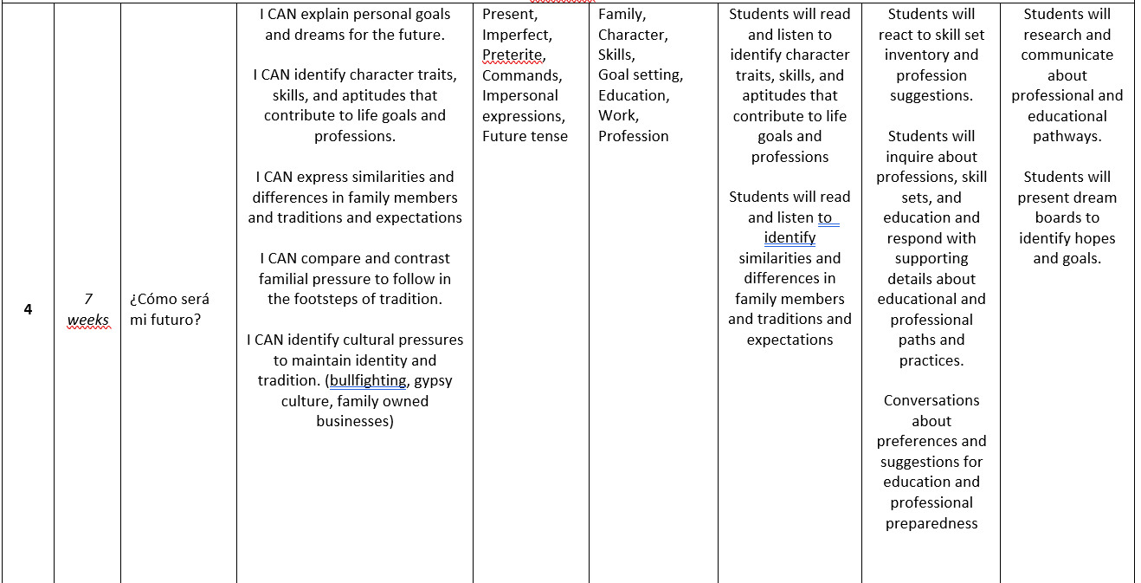

***Baseline: Novice High output***

1. Students will be identifying and communicating future plans regarding education, profession, family, and lifestyle. (Presentational Speaking and Writing)
2. Students will be communicating about their personal goals for adulthood and their definition of happy and successful. (Presentational Speaking and Writing) and (Interpersonal Speaking)

***Growth: Intermediate Low / Intermediate Mid input***

1. Students will read articles and listen to audios and videos that share information about young adults seeking higher education and career paths. (Interpretive Reading and Listening)
2. Students will read articles and listen to audios and videos that share information about the stereotypical professions and pressure to follow in traditional paths. (Interpretive Reading and Listening)
3. Students will read articles and listen to audios and videos that share information about teens making changes to change their culture and traditions. (Interpretive Reading and Listening)
4. Students will read about the gypsy culture and the stereotypes that make change difficult. (Interpretive Reading)
5. Students will read about the changes in the bullfighting industry and the effect that had on family traditions and professions. (interpretive reading)

***Baseline and growth: Novice High/ Intermediate Low output***

1. Students will write about what they have learned including details and personal connections. (Presentational writing)
2. Students will have conversations with peers and teacher about the articles and include opinions and supporting details (Interpersonal speaking)

***Growth: Novice High to Intermediate Low to Intermediate Mid***

1. Students will get direct instruction on the past tense so they are able to communicate about what they wanted to be when they grow up and what they want to be now.
2. Students will complete grill and drill practice to improve ability to communicate in the past tenses.
3. Students will get direct instruction on the Future tense and Conditional tense in order to be able to communicate what they WILL DO or WOULD DO in the future.
4. Students will complete some grill and drill practice on the Future and Conditional tenses.

***Growth: Novice High to Intermediate Low to Intermediate Mid to “visting” Intermediate High***

1. Students will express their preferences and support their opinions on their future selves. (Presentational Speaking and Writing) and (Interpersonal Speaking)
2. Students will communicate some changes that have been made in order to combat stereotyping and gender based employment opportunities. (Presentational Speaking and Writing) and (Interpersonal Speaking)
3. Students will compare and contrast the cost of education in some countries and explain positives and negatives to the cost of college but the stigma that goes along with not going to college. (Presentational Speaking and Writing) and Interpersonal Speaking)

**Teacher goals based on MOPI training:**

Change wording of prompts. What are you doing after high school? 🡪 Tell me what you want to do after high school and how you plan to make that happen.

What did you do to help the Earth? 🡪 Tell me about a change you have made to be more mindful of the Earth.

What do you want to do in the future? 🡪 Tell me about YOU in 10 years from now.

**Teacher goals based on Assessment training:**

Provide assessments using questions at all levels. Lists, phrases, sentences, sentences with details, sentences with details with time stamps.

**Teacher goals for classroom organization and better questioning techniques:**

Classroom warmup activity that promotes question asking practice.

Provide a list of questions for students to pair and share and solidify Novice High accuracy

Classroom warmup activity that promotes vocabulary growth.

Questions that promote responses in complete sentences.

Ex: How has the gypsy culture changed? How have the anti-bullfighting laws affected family traditions and professions?

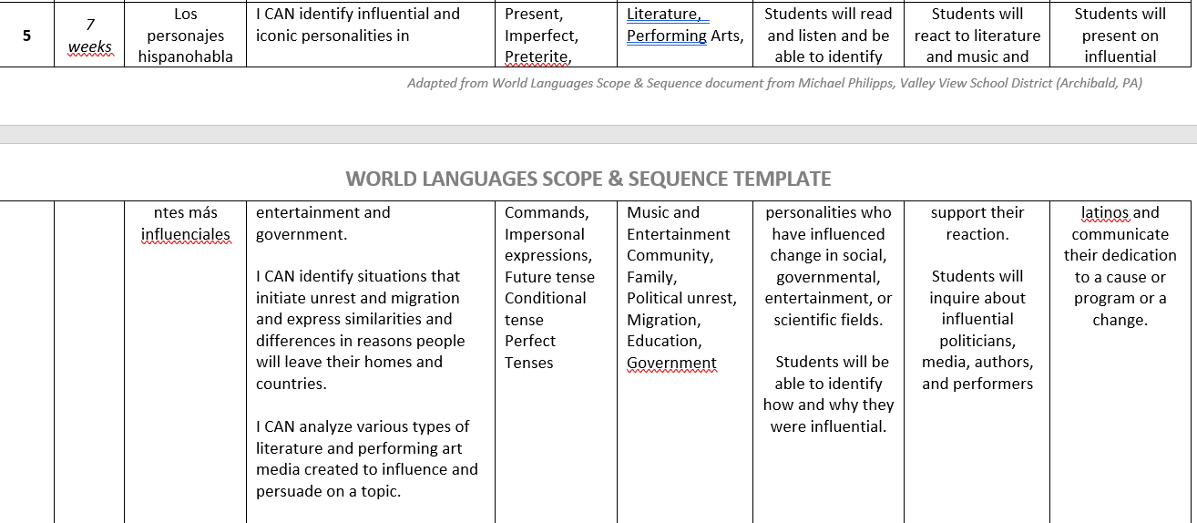

***Baseline: Novice High output***

1. Students will be identifying and communicating about iconic Latinos who have made an impact on entertainment, science, or politics. (Presentational Speaking and Writing)
2. Students will be communicating about their preferences / interest levels in athletes, musicians, actors, scientists, politicians who have a Hispanic background. (Presentational Speaking and Writing) and (Interpersonal Speaking)

***Growth: Intermediate Low / Intermediate Mid input***

1. Students will read articles and listen to audios and videos that share information about athletes, actors, musicians, scientists, and politicians with a Hispanic heritage. (Interpretive Reading and Listening)
2. Students will read articles and listen to audios and videos that share information how world sporting events are breaking down barriers between languages. (Interpretive Reading and Listening)
3. Students will read articles and listen to audios and videos that share information about musicians who are performing in multiple languages and blending their languages into their art. (Interpretive Reading and Listening)
4. Students will read about the influential movie director Pedro Almodóvar and his world renowned work . (Interpretive Reading)
5. Students will read about the influential Sonia Sotomayor and her work in US politics as a voice for Latinos. (interpretive reading)

***Baseline and growth: Novice High/ Intermediate Low output***

1. Students will write about what they have learned including details and personal connections. (Presentational writing)
2. Students will have conversations with peers and teacher about the articles and include opinions and supporting details (Interpersonal speaking)

***Growth: Novice High to Intermediate Low to Intermediate Mid***

1. Students will get direct instruction on the past tense so they are able to communicate about what these influential people did in the past to become the successful people they are today.
2. Students will complete grill and drill practice to improve ability to communicate in the past tenses.
3. Students will get direct instruction on the Future tense and Conditional tense in order to be able to communicate what these people WILL DO or WOULD DO in the future to continue to support their heritage and communities using their fame and success.
4. Students will complete some grill and drill practice on the Future and Conditional tenses.

***Growth: Novice High to Intermediate Low to Intermediate Mid to “visting” Intermediate High***

1. Students will express their preferences and support their opinions on the influential Hispanics and their contributions. (Presentational Speaking and Writing) and (Interpersonal Speaking)
2. Students will communicate some key moments in the lives of these people that have put them into the influential positions that they are now at. (Presentational Speaking and Writing) and (Interpersonal Speaking)
3. Students will compare and contrast some influential Hispanics and the causes they support to improve the lives of others either in their current communities or their homeland communities. (Presentational Speaking and Writing) and Interpersonal Speaking)

**Teacher goals based on MOPI training:**

Change wording of prompts. Who are some famous influential Hispanics? 🡪 Tell me about some of the influential Hispanics we have talked about.

What did X do to help others? 🡪 Tell me about some changes X has been influential in making.

What does X do? 🡪 Tell me about how X will support changes in the future.

**Teacher goals based on Assessment training:**

Provide assessments using questions at all levels. Lists, phrases, sentences, sentences with details, sentences with details with time stamps.

**Teacher goals for classroom organization and better questioning techniques:**

Classroom warmup activity that promotes question asking practice.

Provide a list of questions for students to pair and share and solidify Novice High accuracy

Classroom warmup activity that promotes vocabulary growth.

Questions that promote responses in complete sentences.

Ex: How has the industry been influenced by Hispanics?

How have bilingual (athletes, entertainers, scientists, politicians) been able to maintain their culture and language and share it?

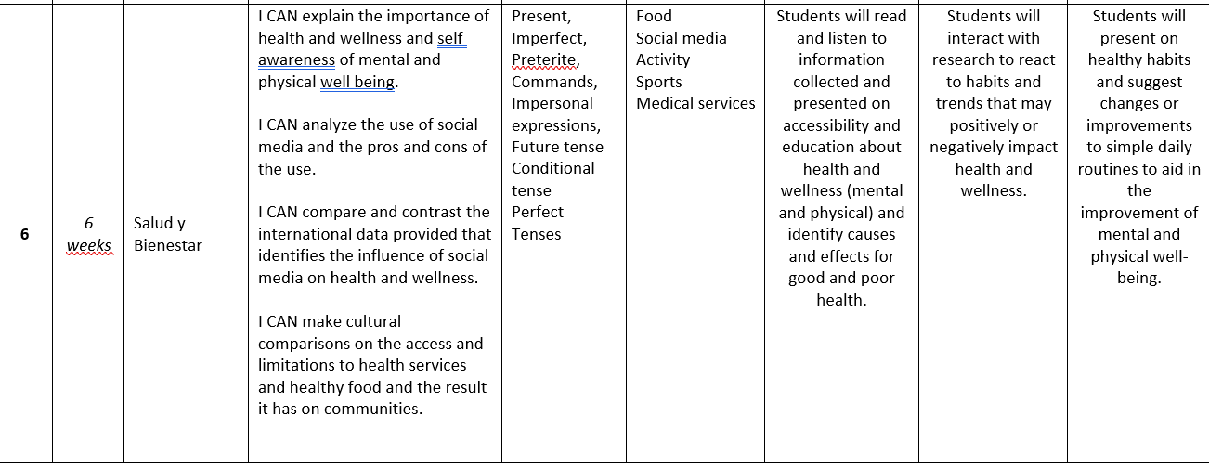

***Baseline: Novice High output***

1. Students will be identifying and communicating about what they eat and the activities they do for positive health. (Presentational Speaking and Writing)
2. Students will be communicating about their preferences / interest levels in athletic activities, food habits, personal self-care, awareness of healthy choices. (Presentational Speaking and Writing) and (Interpersonal Speaking)

***Growth: Intermediate Low / Intermediate Mid input***

1. Students will read articles and listen to audios and videos that share information about the importance of healthy lifestyles. (Interpretive Reading and Listening)
2. Students will read articles and listen to audios and videos that share information how more schools (secondary and post secondary) are offering classes on happiness and personal self care. (Interpretive Reading and Listening)
3. Students will read articles and listen to audios and videos that share information about government programs that are focusing on mental health programs both proactive and reactive. (Interpretive Reading and Listening)
4. Students will read about the influence of social media on mental health. (Interpretive Reading)
5. Students will read about the use of music and exercise to improve mental health. (interpretive reading)

***Baseline and growth: Novice High/ Intermediate Low output***

1. Students will write about what they have learned including details and personal connections. (Presentational writing)
2. Students will have conversations with peers and teacher about the articles and include opinions and supporting details (Interpersonal speaking)

***Growth: Novice High to Intermediate Low to Intermediate Mid***

1. Students will get direct instruction on the past tense so they are able to communicate about what habits they used to have vs. have currently.
2. Students will complete grill and drill practice to improve ability to communicate in the past tenses.
3. Students will get direct instruction on the Future tense and Conditional tense in order to be able to communicate what these people WILL DO or WOULD DO in the future to improve and promote health and wellness.
4. Students will complete some grill and drill practice on the Future and Conditional tenses.

***Growth: Novice High to Intermediate Low to Intermediate Mid to “visting” Intermediate High***

1. Students will express their preferences and support their opinions on the suggestions and research that promote health and wellness. (Presentational Speaking and Writing) and (Interpersonal Speaking)
2. Students will communicate some specific changes they have seen others make to live healthier lifestyles. (Presentational Speaking and Writing) and (Interpersonal Speaking)
3. Students will compare and contrast some programs, educational materials that teach and promote healthy lifestyles. (Presentational Speaking and Writing) and Interpersonal Speaking)

**Teacher goals based on MOPI training:**

Change wording of prompts. What are some healthy choices you make? 🡪 Tell me about some changes in your personal habits you would like to make.

What did you do to change your social media usage? 🡪 Tell me about some changes you or someone you know has made.

What is advice you would like to give to others to promote health and wellness? 🡪 Tell me about how you can support yourself and others in health and wellness.

**Teacher goals based on Assessment training:**

Provide assessments using questions at all levels. Lists, phrases, sentences, sentences with details, sentences with details with time stamps.

**Teacher goals for classroom organization and better questioning techniques:**

Classroom warmup activity that promotes question asking practice.

Provide a list of questions for students to pair and share and solidify Novice High accuracy

Classroom warmup activity that promotes vocabulary growth.

Questions that promote responses in complete sentences.

Ex: What suggestions would you give to promote healthy lifestyles based on age groups?

What can schools do differently to promote health and wellness?

What role should the government play in promotion of health and wellness?